**Oracle Cloud Test Drive Labs**

Process Cloud Service

# PCS Lab

Contents

PCS Lab 2

Introduction 3

Note (for later) 3

1.0 Logging in to PCS 4

2.0 Create the Process 6

3.0 Create the Order Business Object 10

4.0 Create the Order processing form 15

5.0 Create the Order Process – The Happy Path 20

6.0 Testing 30

7.0 Adding Process logic 37

Congratulations– You have finished the Lab ! 51

Bonus Labs 52

8.0 Importing the solution 52

9.0 Document Cloud Service Integration 55

## Introduction

In this lab, you will create a business process using PCS. This Order Approvals process will be initiated when a user enters an order. The business logic is as follows:

* Small orders, those < £ 100, will be automatically approved.
* All other orders, let’s call them large, need to be manually approved.
* If an order is rejected, it needs to be sent to Management for a final decision.

There are 3 functional roles within this process –

* OrderEntry
* OrderApproval
* OrderManagement

## Note (for later)

Here is the XSD, defining an Order, you will need to simply copy and paste it later. Skip it for now.

|  |
| --- |
| <?xml version="1.0" encoding="windows-1252" ?>  <xsd:schema xmlns:xsd="http://www.w3.org/2001/XMLSchema" xmlns="http://www.example.org"  targetNamespace="http://www.example.org" elementFormDefault="qualified">  <xsd:element name="Order">  <xsd:complexType>  <xsd:sequence>  <xsd:element name="orderNr" type="xsd:string"/>  <xsd:element name="custFirstName" type="xsd:string"/>  <xsd:element name="custLastName" type="xsd:string"/>  <xsd:element name="custEmail" type="xsd:string"/>  <xsd:element name="product" type="xsd:string"/>  <xsd:element name="unitPrice" type="xsd:int"/>  <xsd:element name="quantity" type="xsd:int"/>  </xsd:sequence>  </xsd:complexType>  </xsd:element>  </xsd:schema> |
|  |

## 1.0 Logging in to PCS

**Your instructor will assign you a Group (1 or 2) and a user and password for logging in.**

Your instructor will also assign a Prefix – you will not need it for now, only for later

To avoid any possible cache issues –

* In Chrome - Select New Incognito Window
* In Mozilla - Select New private  window
* In IE – Safety 🡪 InPrivate Browsing

Login with your assigned user name and password

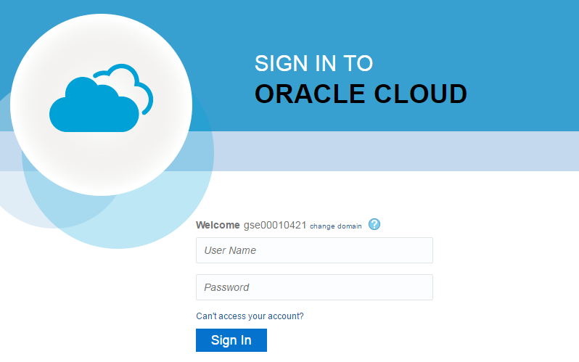

If you should see this screen:

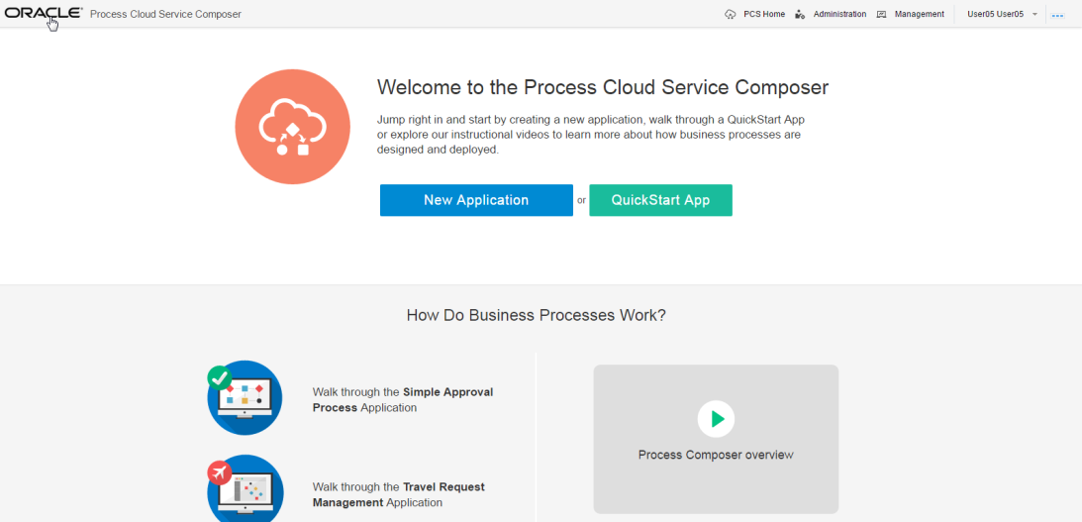

* Click on the **Oracle** logo on the top left of the screen.

If you see this screen:

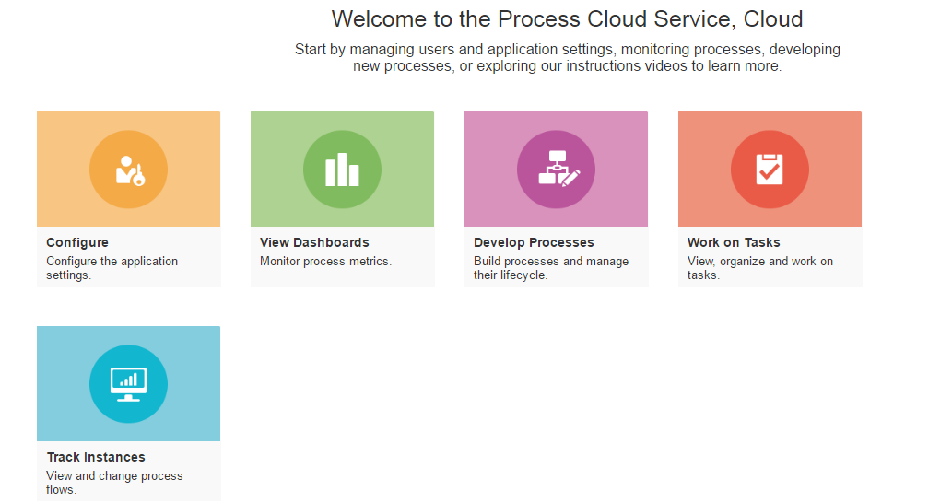

* Click on **Develop Processes**

Note: the above screenshot shows the PCS launch page. From here you can do develop processes, work on tasks e.g. approve orders that have been assigned to you. One can also monitor what is going on via tracking.

You should see the following **Process Composer** screen.

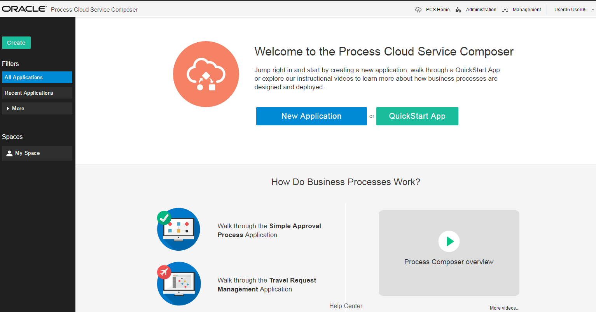

## 2.0 Create the Process

Let’s get started, first we will create a Space. This is similar to creating a project where all the related artefacts are grouped together.

* Click on the “**Create**” button at the left

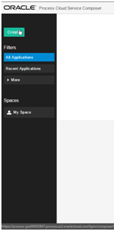

* Select to Create a **New** **Space**

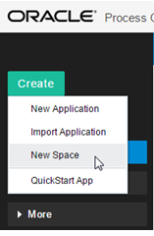

* Call the new Space ***XX***OrdersSpace, ***XX*** being the prefix assigned to you by the instructor.

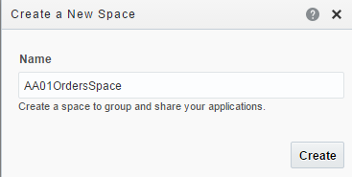

* Click on the newly created **Space**

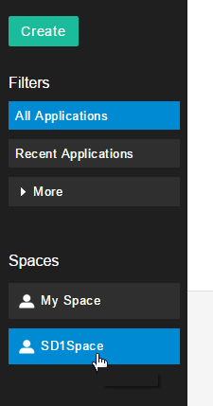

* Click on **New Application**

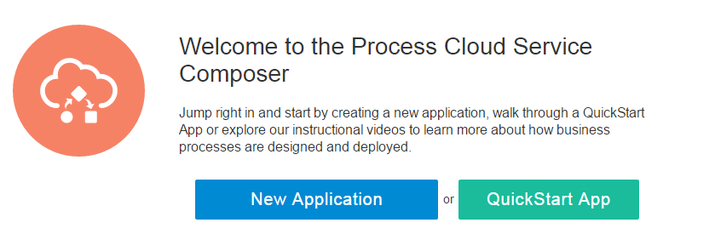

* + **Enter XXOrdersApp** (where XX is the prefix assigned to you)

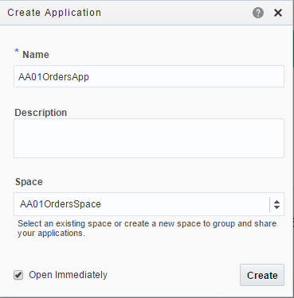

* Click **Create**

You should see the following screen

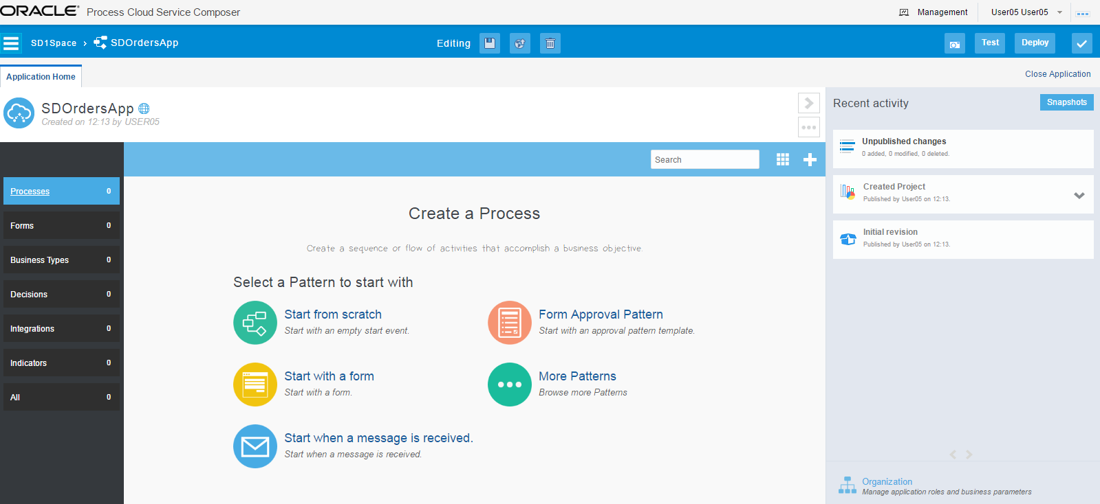

### 3.0 Create the Order Business Object

* Click on **Business Types** to add the Orders XSD to this application (left hand side of the screen).

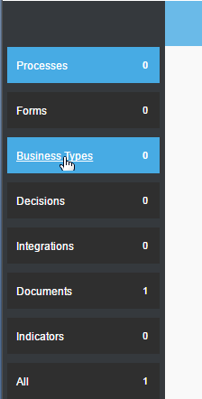

* Click on **Schema Files**

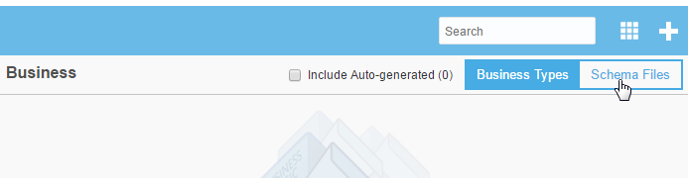

* Click on the + to add the XSD

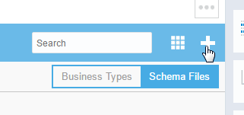

* Add NCOrder.xsd – this file is in the ***downloads*** folder. As an option you can also create an XSD using the definition at the start of this document (create a text file, cut & paste and rename as NCOrder.xsd)

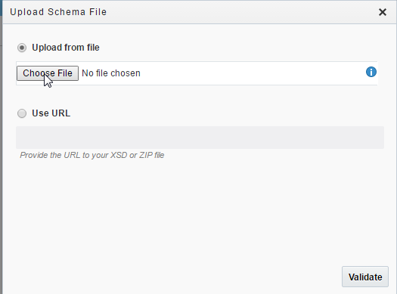

* Click **Validate**

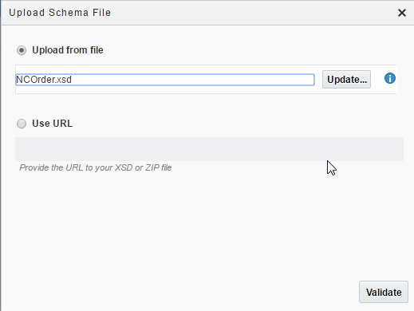

* Click **Upload**

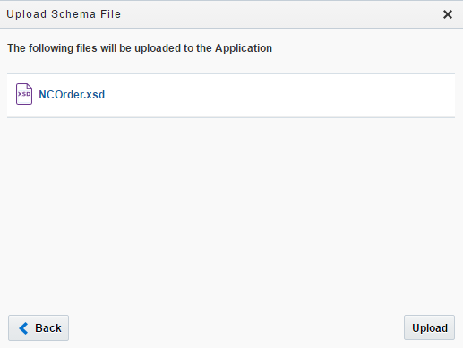

Note: The XSD has been successfully uploaded

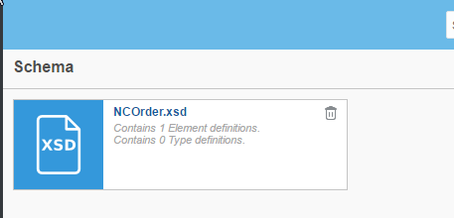

* Click on the XSD

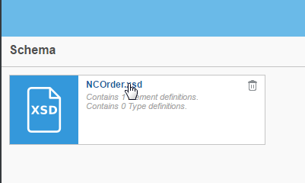

* Click on the **Promote** link

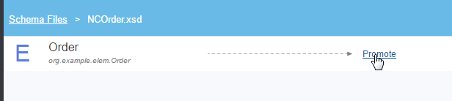

Note: This creates a PCS business object from the Order definition within the XSD.

* Name it **OrderBO**

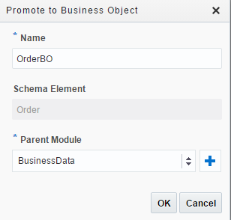

* Click **Ok**

Well done! You have successfully created your first PCS business object. This process could have been done in a graphical way too but we are using the imported file to save some time.

### 4.0 Create the Order processing form

* Click on **Forms** at the left

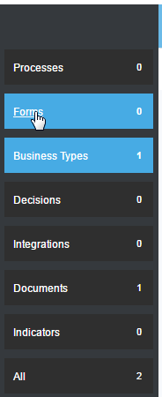

* Click on the plus button to create a new form

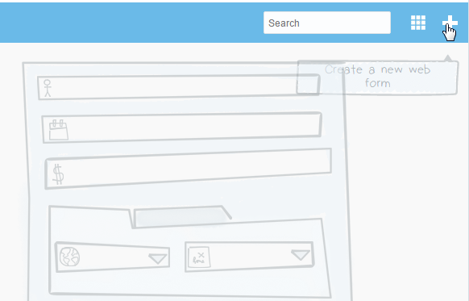

* Click on **New Basic Form**

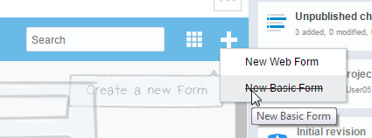

* Name the Basic Form **XXOrderBasicForm** and click ‘create’

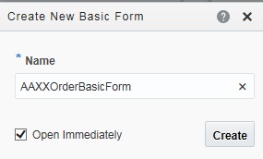

Note: the screenshot shows the forms designer. Now you will add the Order business object to the form.

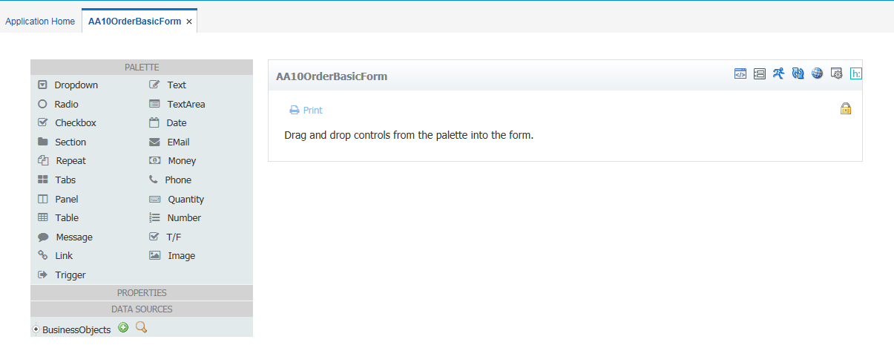

* Click on the **Manage Business Objects** button, located at the top right of the page.

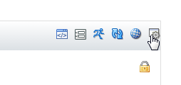

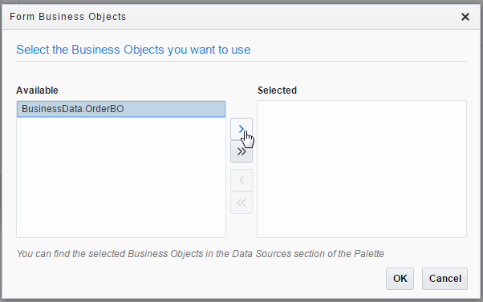

* Click **OK**
* Expand Business Objects in the palette (appearing at the bottom left of the tools menu). Click on the word “**Business Objects**” to expand it, not the ‘+’ sign.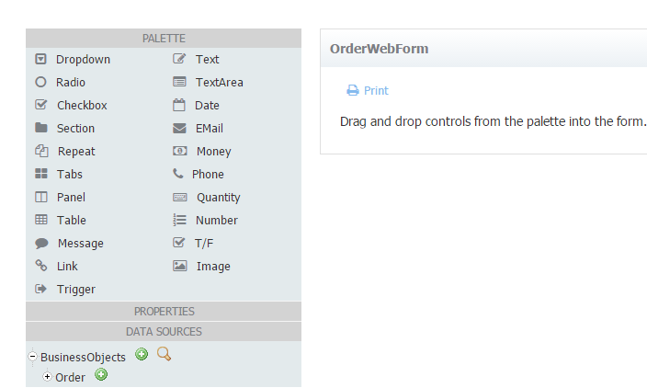
* Add the Order to the form. Click on the **+** as shown below. This will add the business object and all its fields to the form.

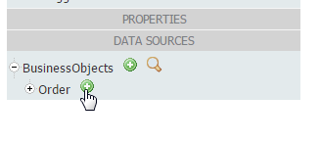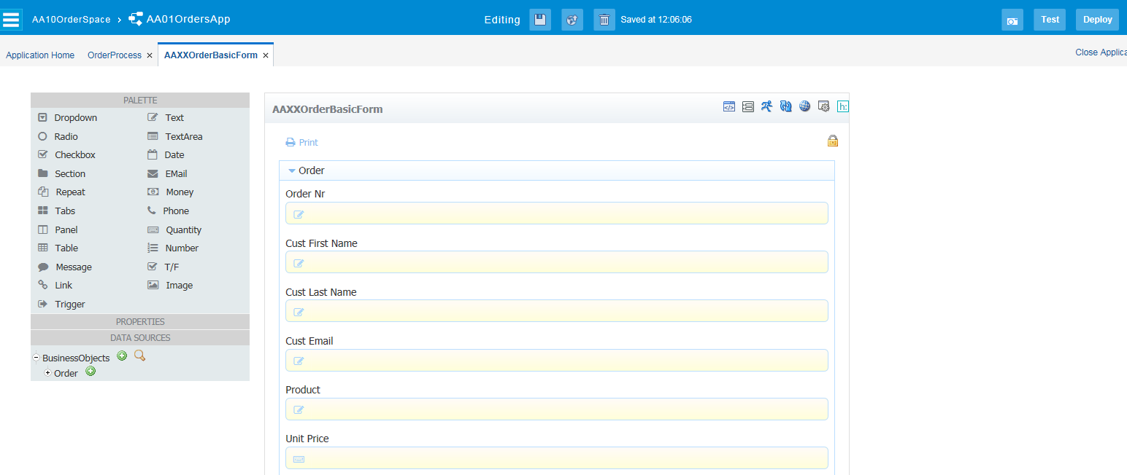

Note: You can, of course, configure each field’s properties via the palette. However, just leave, as is, for now.

* Click **Save**



* Click the **Application Home** link/Tab

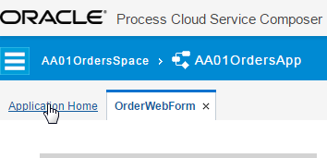

You will see your new form.

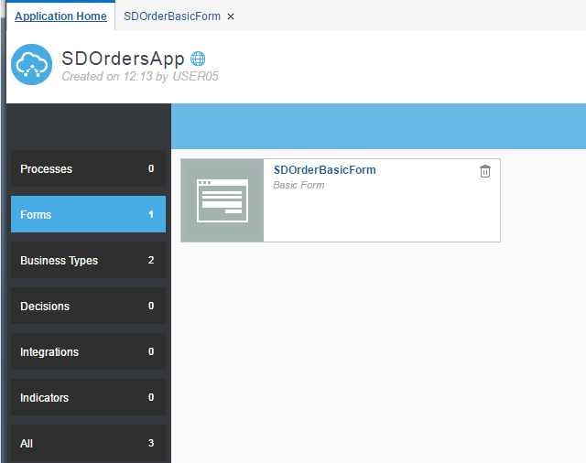

### 5.0 Create the Order Process – The Happy Path

Now, you will create the process.

* Click on **Processes**
  + You will select **Start with a form**

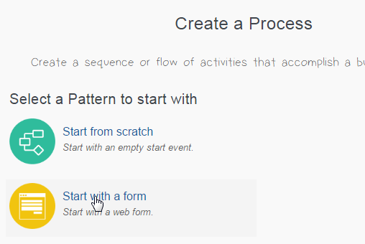

* Name the process **OrderProcess** - make sure the **Form** pattern is selected andclick **Create**

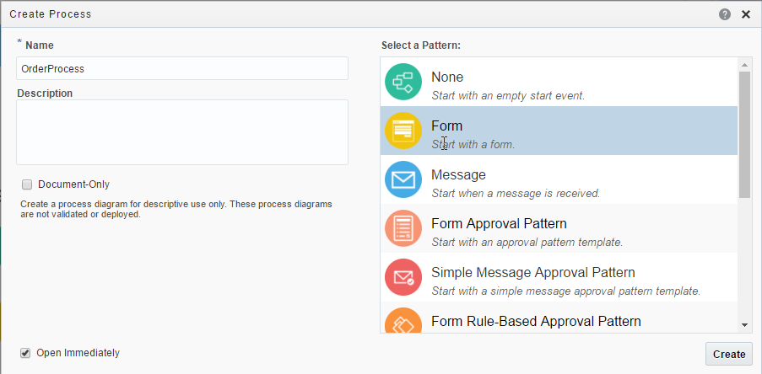

You will see your basic process.

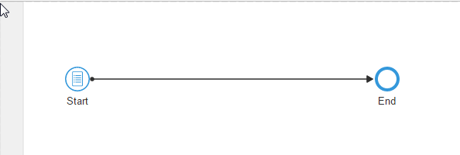

#### Add Process Roles

The work that is assigned to the various users of the system is defined by their ‘Role’. In BPMN terminology a role is mapped to a ‘swimlane’, and an activity that is in that swimlane is delivered to any user (or users) who log into the system with that role at the appropriate time.

The default process has one swimlane. Let’s add two more.

* Click the ‘+’ icon twice

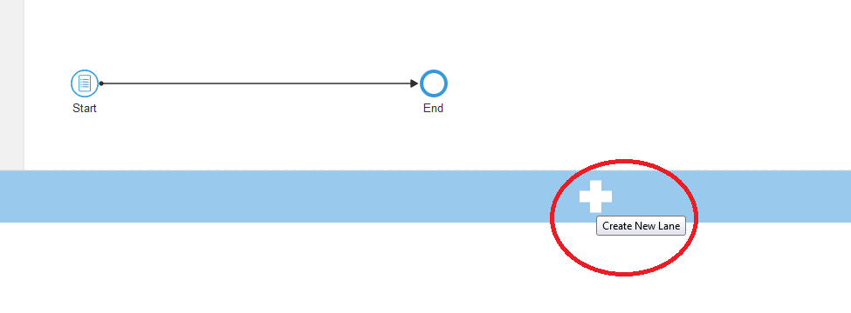

You should see this.

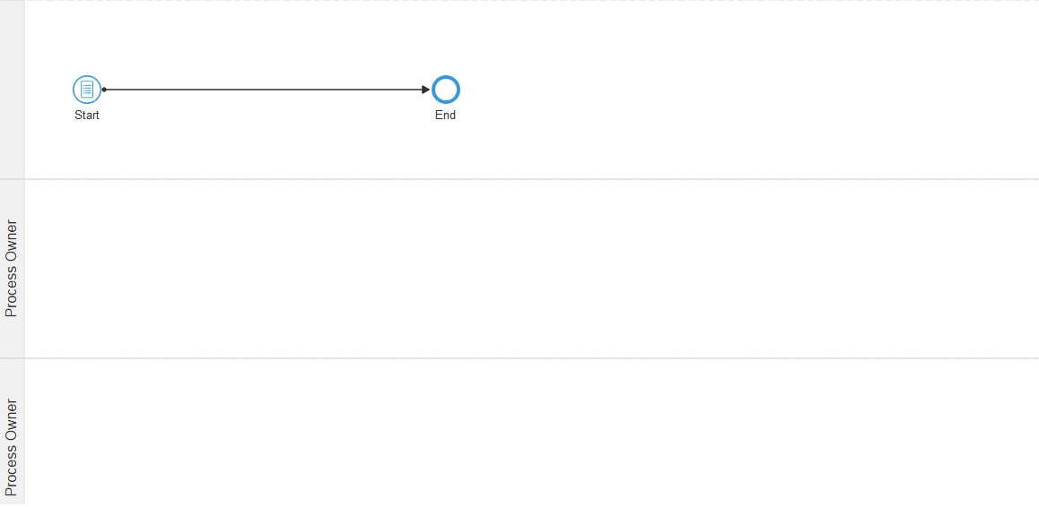

Now we will add the three roles mentioned in the introduction; ‘Order Entry’, ‘Order Approval’ & ‘Order Management’

* Click on the left hand side of the first lane – it will turn blue.
* **Double Click** on the blue area – this will allow you to edit the lane Role.
* Enter ‘Order Entry’

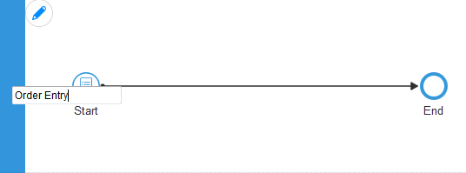

* Do the same for the next two Lanes so that your map looks like this.
  + Order Approval
  + Order Management

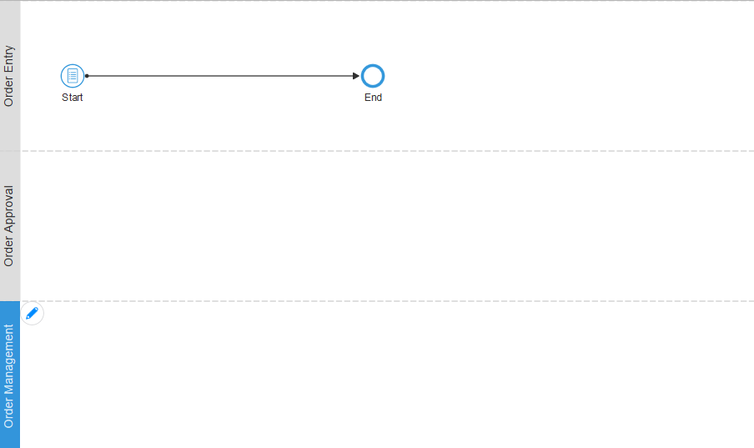

#### Add the Process logic

For the start event, we simply need to point to the Basic Form you created.

* Specify the form to use

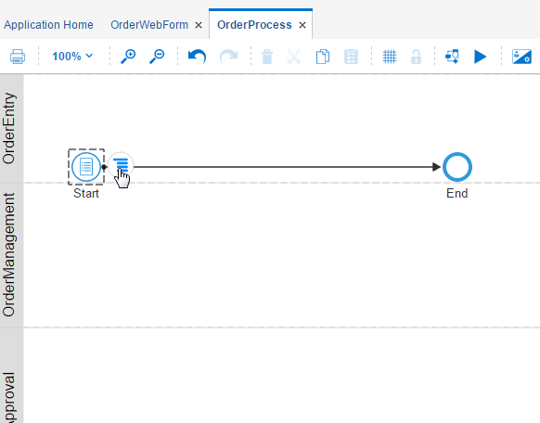

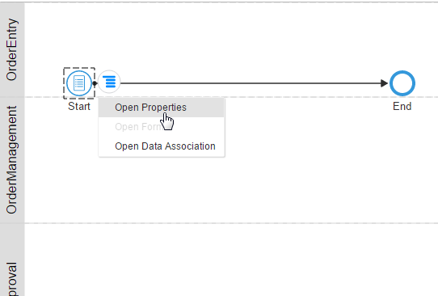

* Enter a title– **Order Entry Form** - then browse to select the form previously created

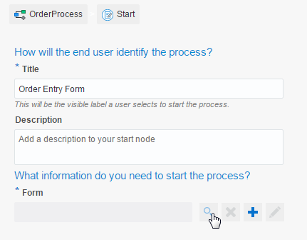

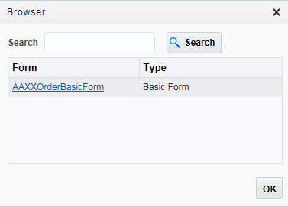

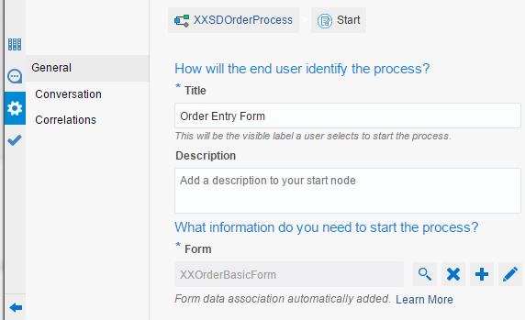

* Minimize the properties panel 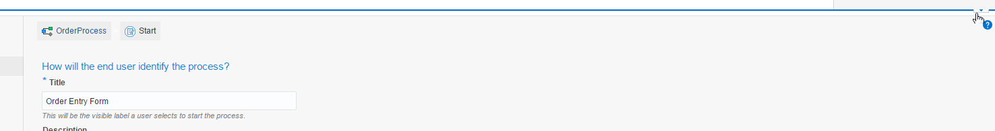and Click Save  
* Rename the activity from **Start** to **Enter Order** (**double click** on Start)

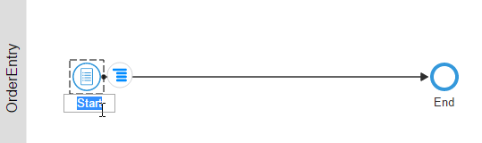 should become

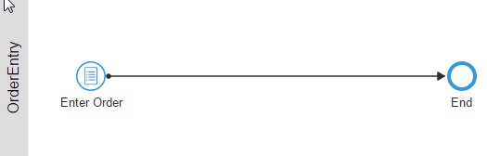

Now you will implement the business logic to approve an order. Remember, the **OrderApprovers** do this.

* Select an **Approve** task in the right hand palette.

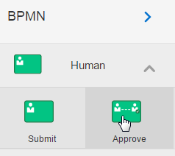

* Drag the task onto the line connecting **Enter Order** to **End** – when the line will flashes blue, drop the task onto the line.

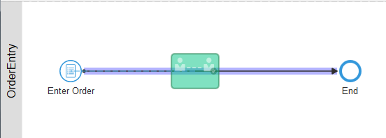

* Drag the user task to the **OrderApproval** Lane

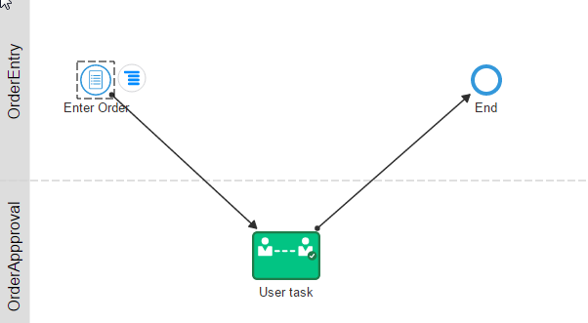

* Rename **User Task** to **Approve Order**

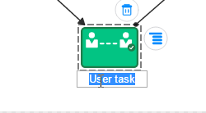

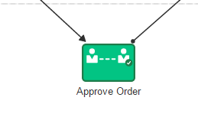

* Click the **Validate Application** icon
  + Top right, last icon

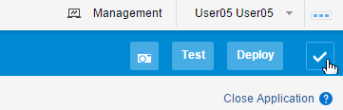

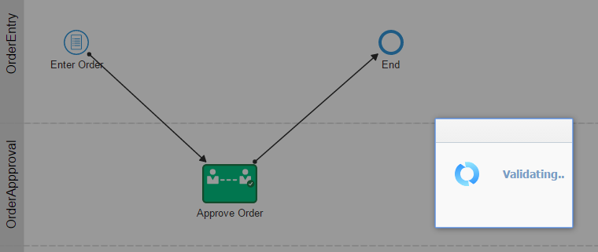

You should see this...

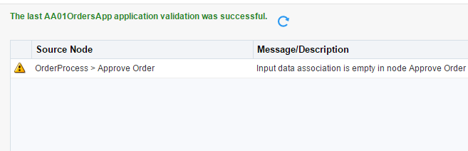

This tells you that the process logic is OK, but it warns you that you have not associated any data with this person’s task – in this case we want the Order data for the approval task. This is done automatically when we assign a Form to the task.

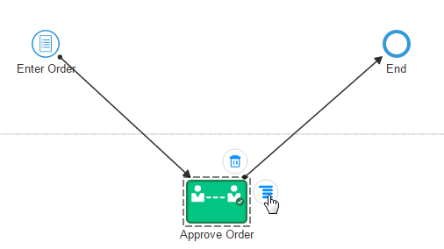

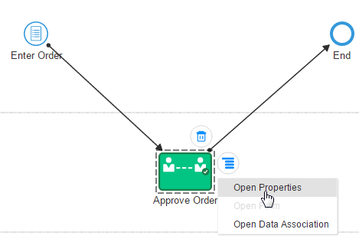

* Enter Title – **Approve an Order**
* Select the same form (at the “Basic Form” property click on search)

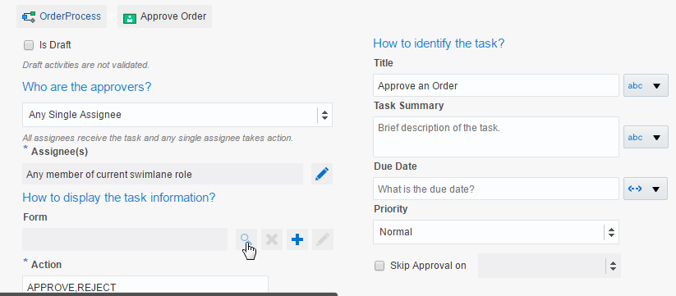

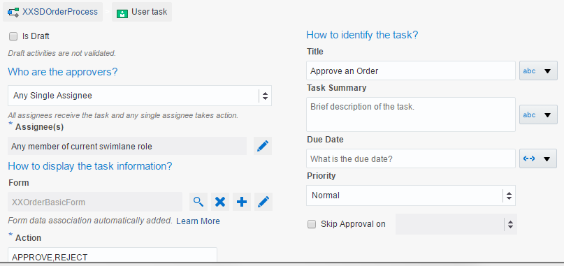

* Click **Save**
* Collapse the Properties pane (small icon to the right)
* **Validate** again

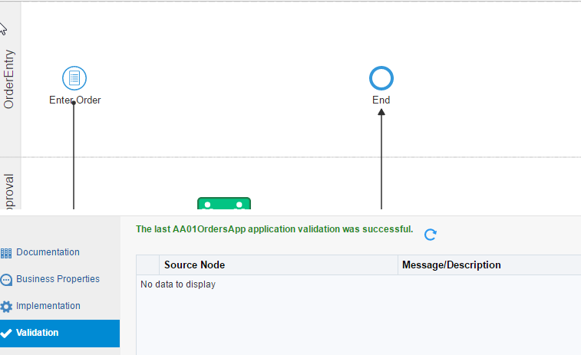

### 6.0 Testing

* Click **Test**

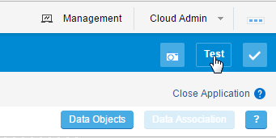

* Click **Deploy**

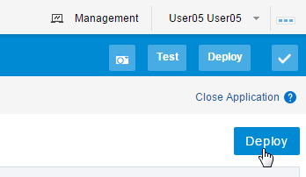

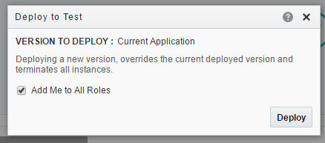

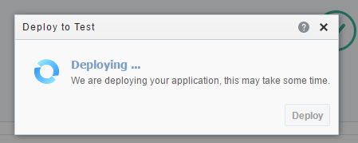

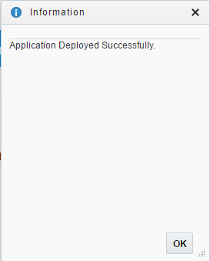

Note: You have 2 options for testing, either within the Composer itself via Play, or using the PCS Workspace. The Workspace is the default interface used to approve tasks and monitor process execution.

* Select **Try in Workspace**

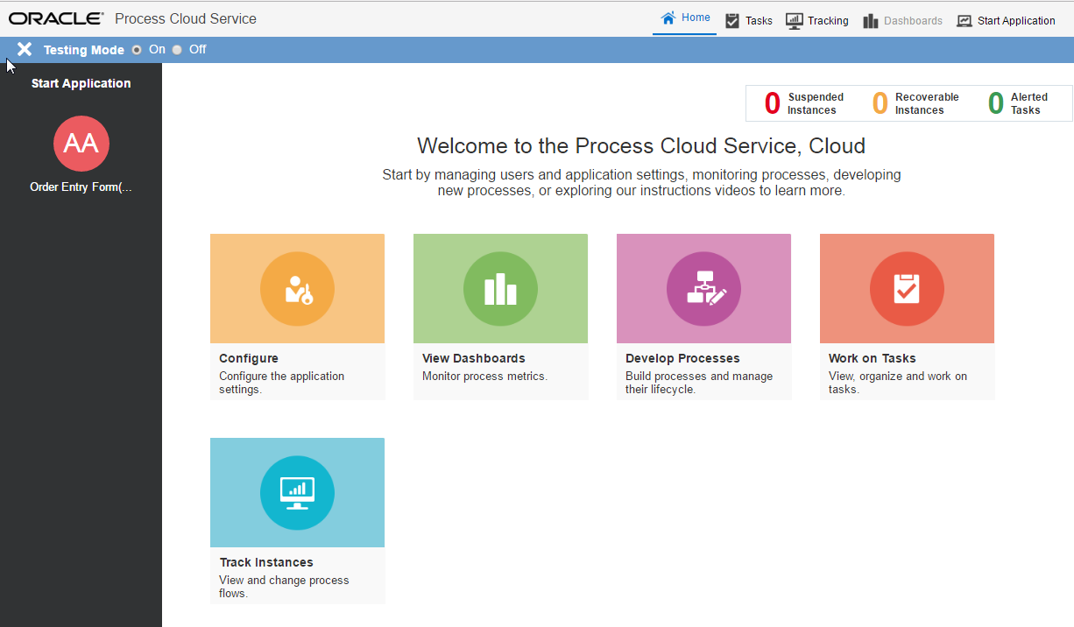

**Note: the** **Start Application** panel on the left, shows you the applications which you can start.

* Click on the icon that corresponds to your App – XX Order Entry Form

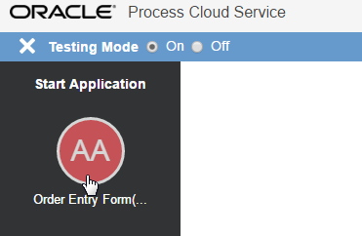

* Fill in all the fields, then click **Submit**

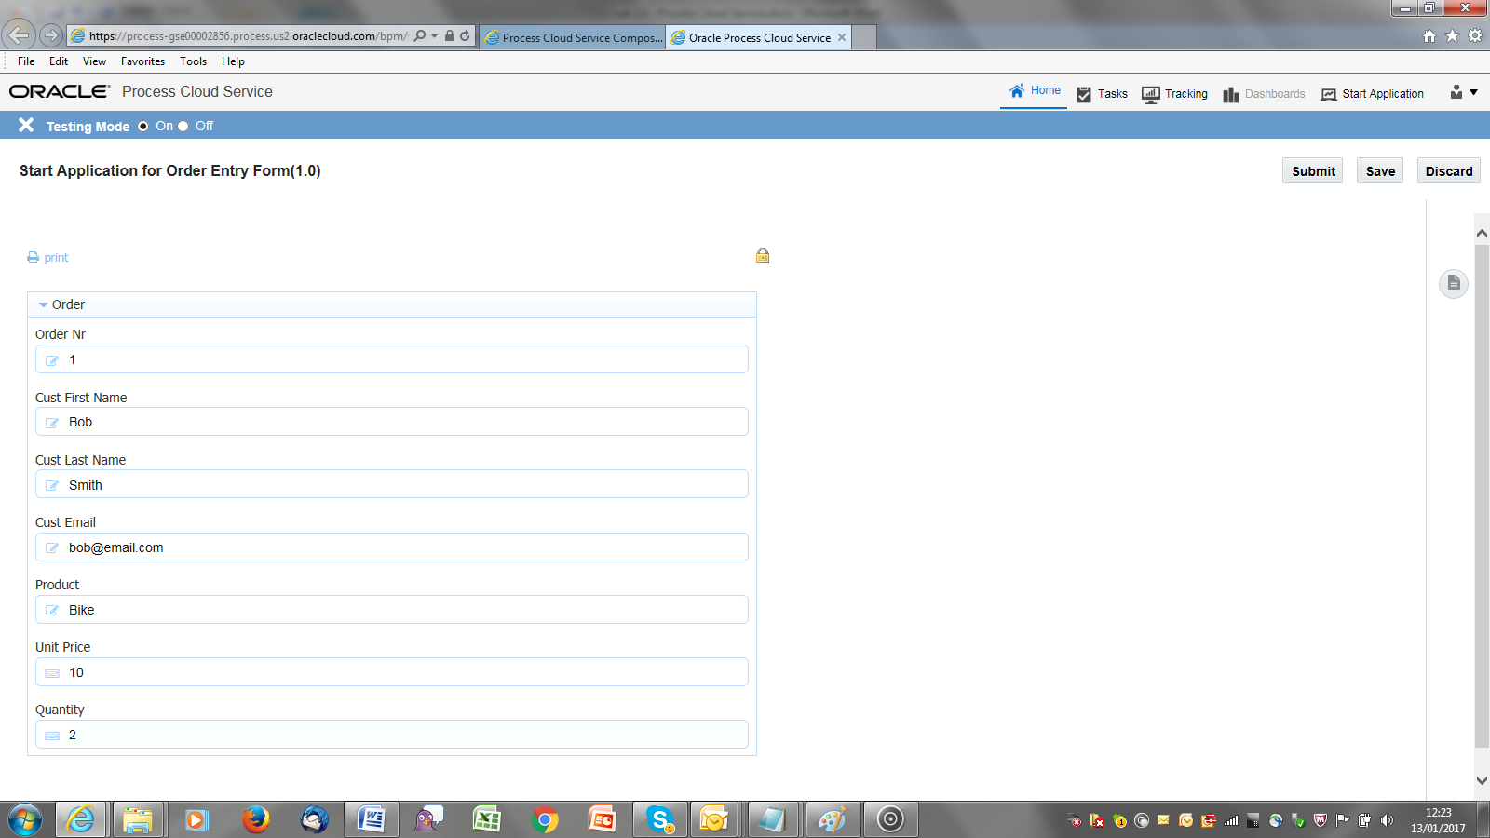

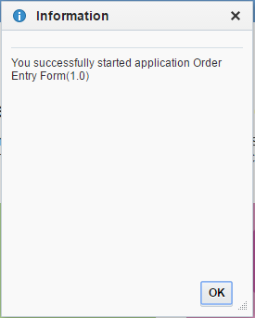

Note: As you are testing, your user has been added to all process roles, so you can approve the order.

* Click **Work on Tasks**

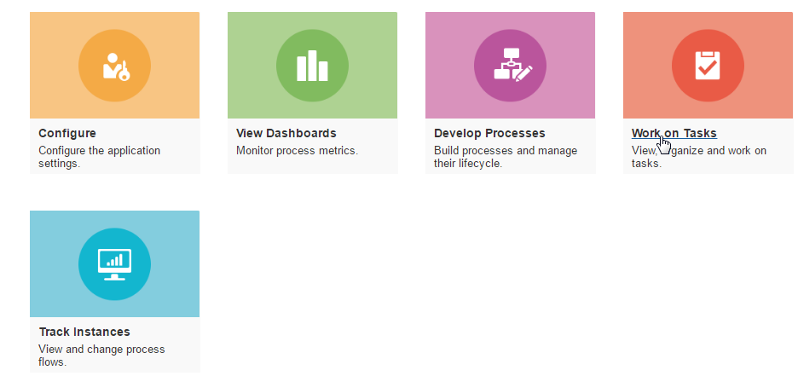

Note: The “**Approve order task**” will be displayed. Search criteria can be specified in the left panel. Here, one can, for example, also search for completed instances.

But back to the task at hand, let us approve the order.

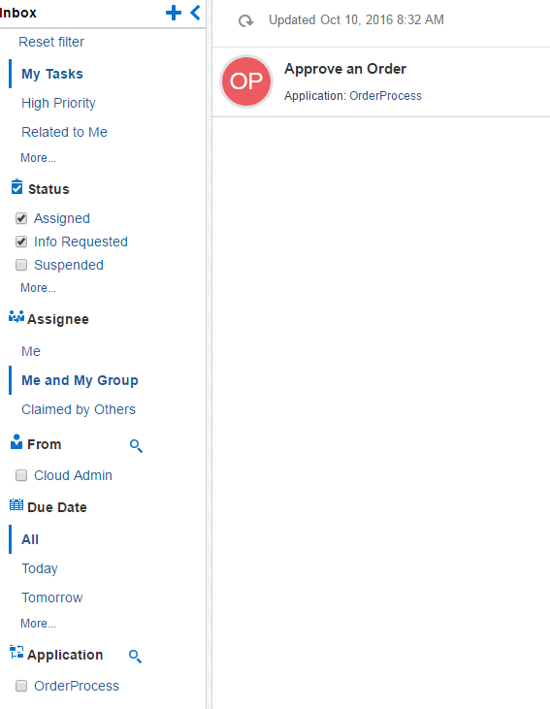

* **Click** on the **>** icon to see the details

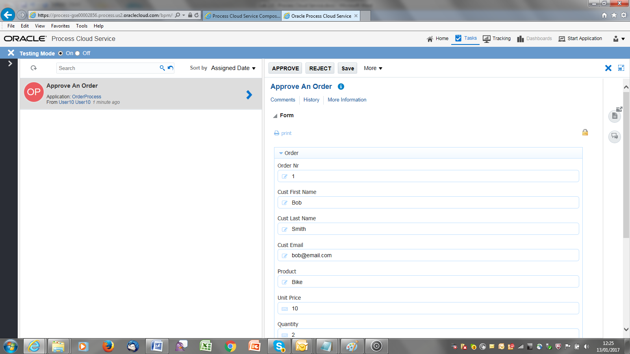

* **Approve** the order



You will now view the process audit trail.

* Click on **Tracking**



* Also select **Completed**

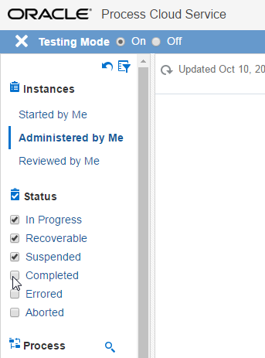

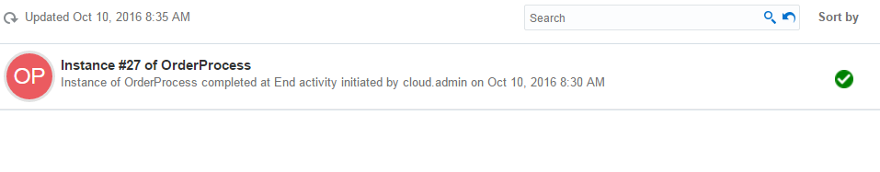

* **View** the process instance details

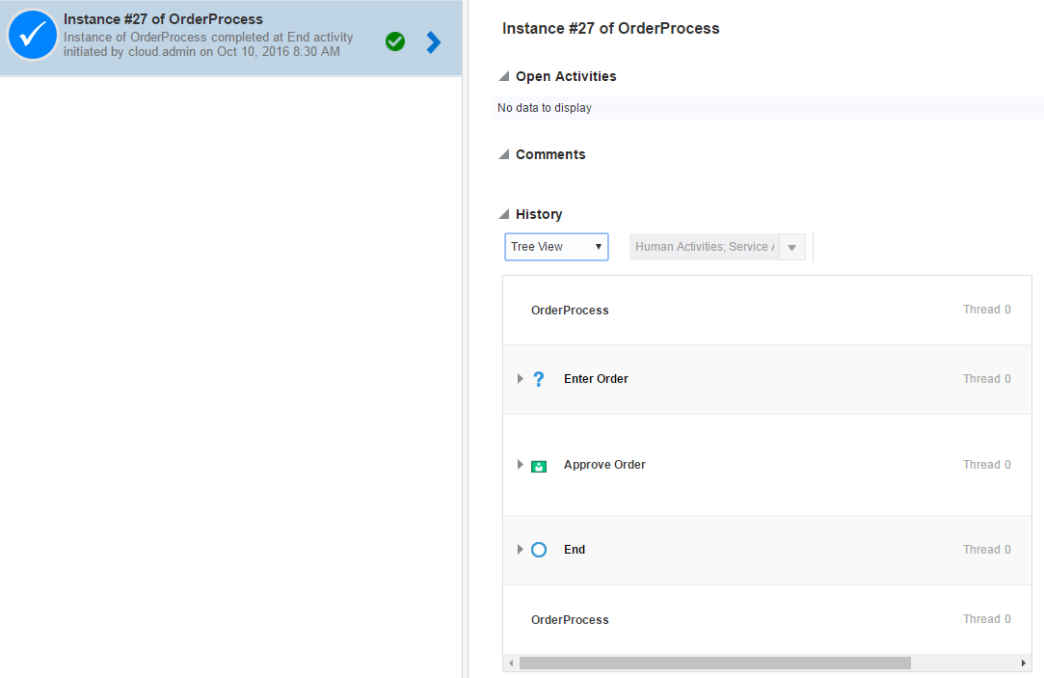

### 7.0 Adding Process logic

Here you will add the logic to automatically approve orders < €100.

* Click Home at the top 🡪 Develop Processes (open up your **Application)**
* If you see this pop up – click on Return to Application 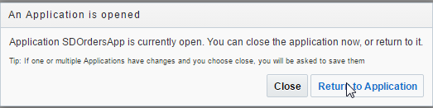

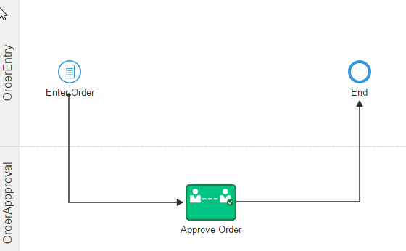

* Add a Decision Gate, based on the order value

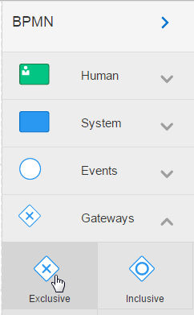

* Drop this onto the link between **Enter Order** and the **Approve Order** task.

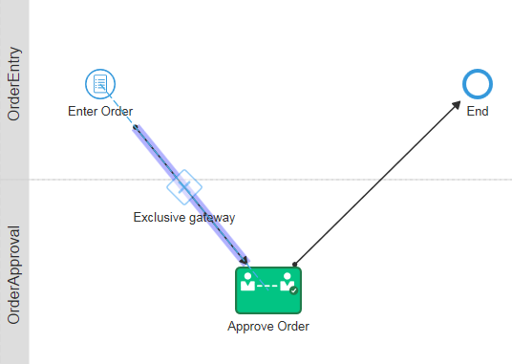

* Drag the gateway into the **OrderEntry** swimlane and click and hold the ‘connections’ arrow.

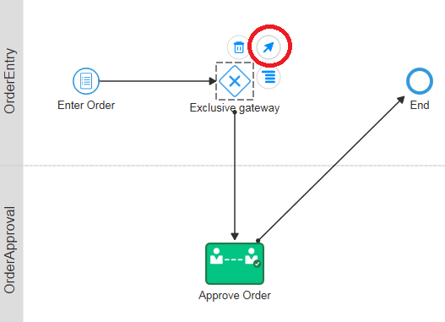

* Drag to the **End** step to connect them

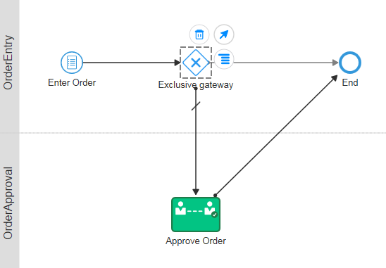

* Enter a condition on the Approval path. Note, the ‘slash’ on this path indicates that it is currently the default (or unconditional) path. Double click on the link.

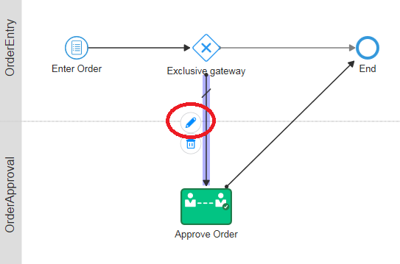

* Enter **Large Order** as the name and then open the **Expression Builder** to edit the ‘condition’ under which this path is followed. Select ‘Conditional Flow’

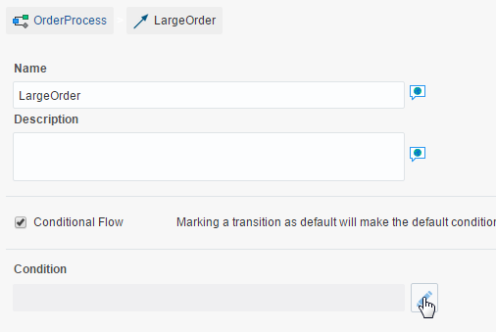

* Click on the “**XXOrderBasicFormDataObject**” to expand the payload, then on **OrderBO**

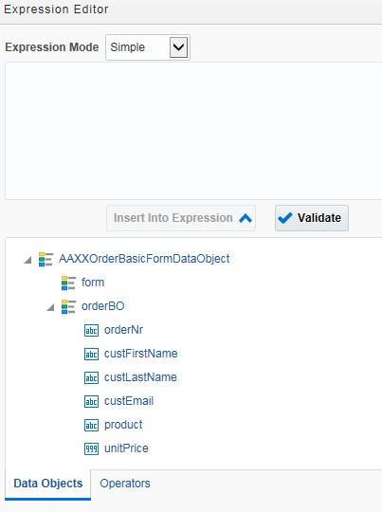

Note: The condition is unitPrice * quantity >= €100.

* Find the **unitPrice** object in the payload and select it
* Click on “**Insert Into Expression**”

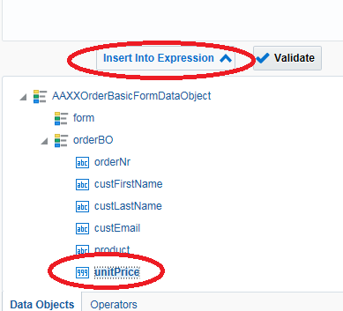

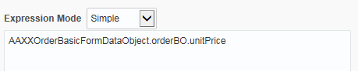

* Manually add the multiplication symbol **\*** into the expression builder

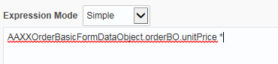

* and then find the **quantity** object from the Data Objects and insert it into the expression

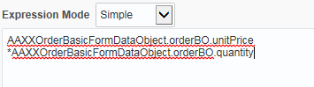

* Then complete the condition by adding **>= 100**

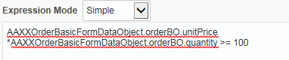

* Click validate to check it is correct syntax
* Click **OK** (at the bottom) and click **Save**
* Minimise the entry panel
* Finally, remove the condition on the straight-through route.

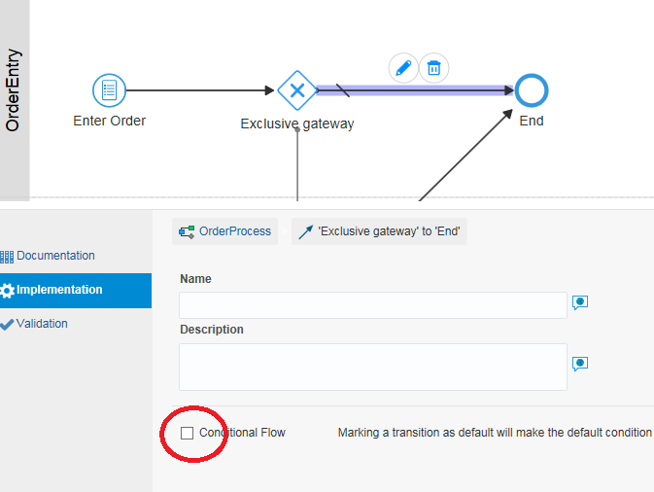

Now you will add the logic to escalate **REJECTED** orders to management.

* Add an **Exclusive Gateway** after the Approve Order task

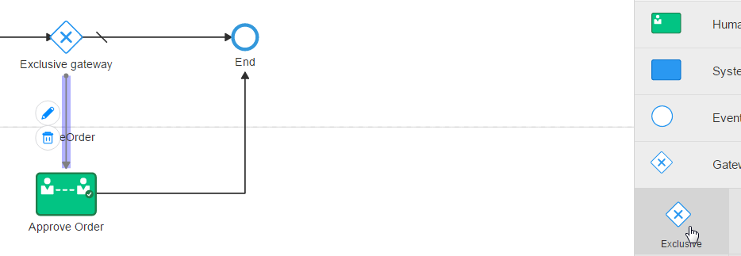

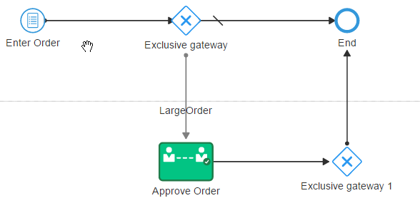

* Add a new Approval Task to the **OrderManagement** swimlane
  + Configure as per the Approve Order task, except for giving it a different name – ‘Management Approval’.

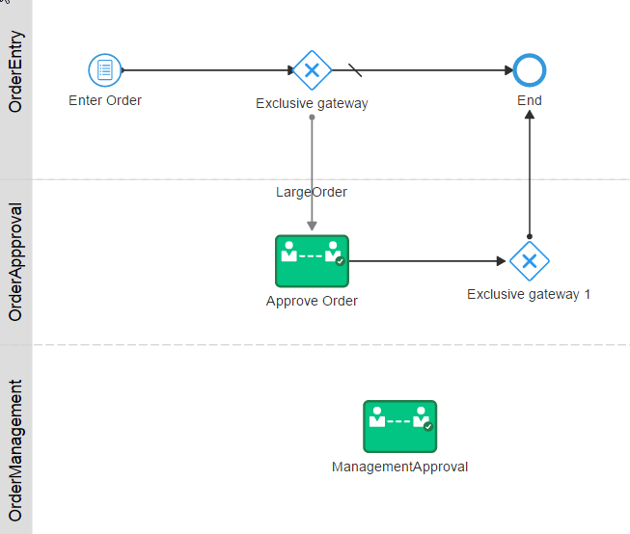

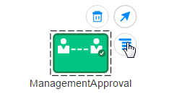

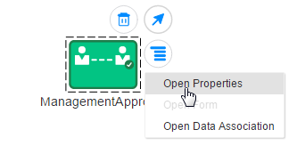

Populate the Title to **Management Approval**

Then add the Order Approval form in the “**Form**” field

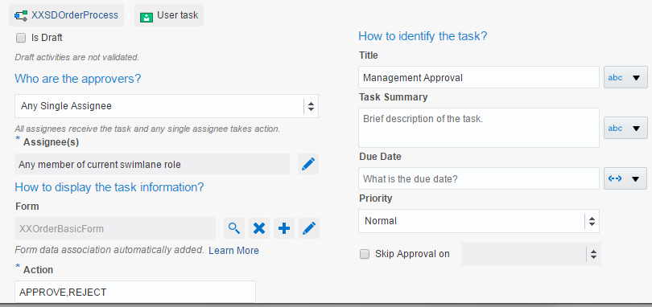

* Click **Save**
* Minimize the Panel
* Click and hold the arrow and then drag to connect it to the Management Approval as follows

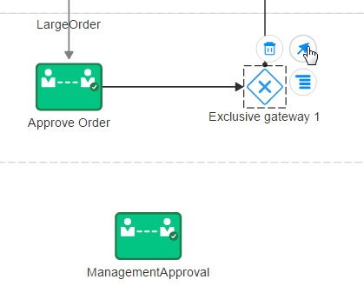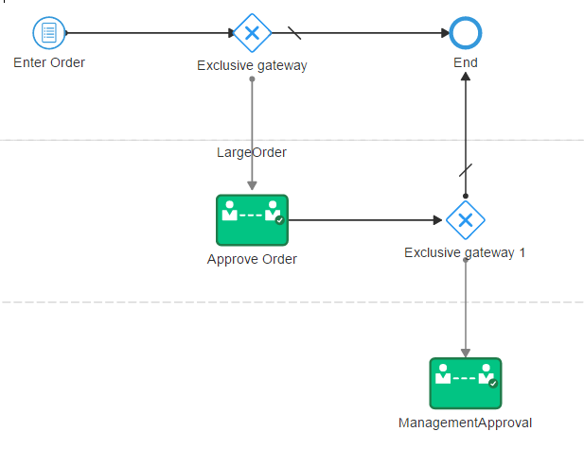

* Rename the **Gateways**

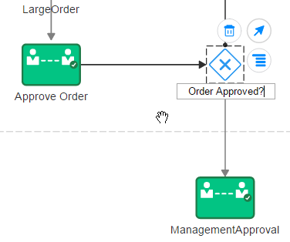

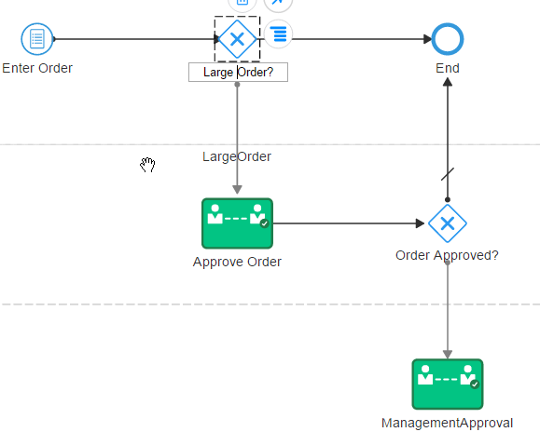

* Enter the condition for Management Approval

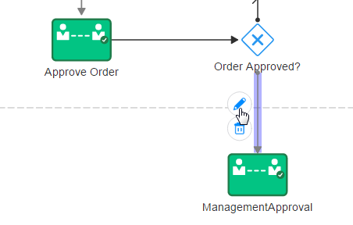

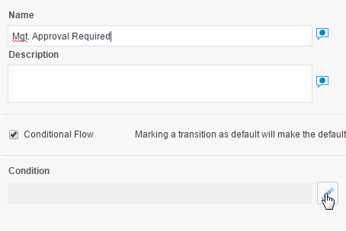

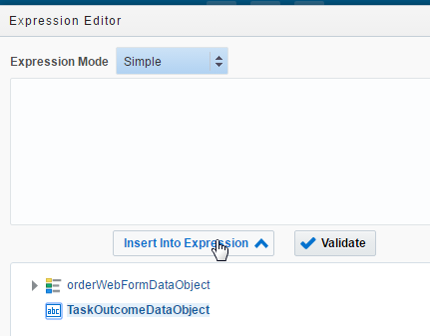

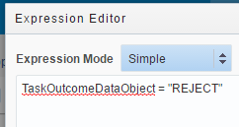

* Click **Ok** and **Save**
* Minimise the panel
* Add a path between **Management Approval** and **End**.

Note: You probably would require yet another Gateway here for a Management Approval ‘Reject’ option, but for the sake of time, do not implement this.

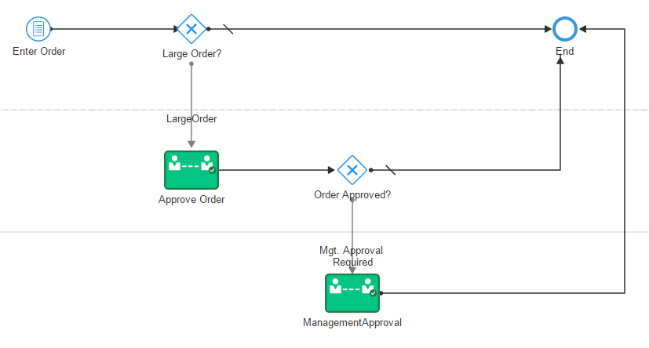

* Validate your process

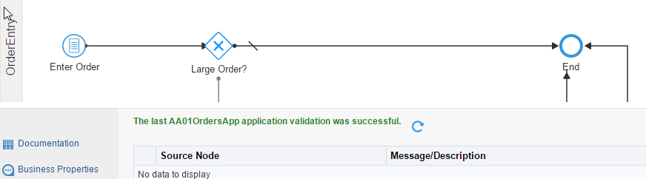

* Click on **Test** 🡪**Deploy** (remember to use the ‘Deploy’ in the test page)🡪 **Try in Workspace**

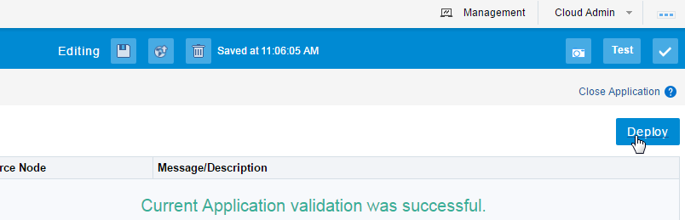

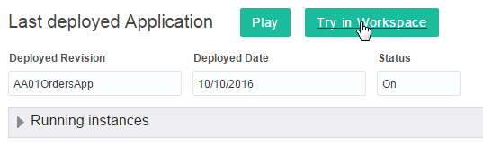

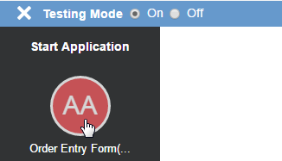

* Enter a small order that will have a value less than £100

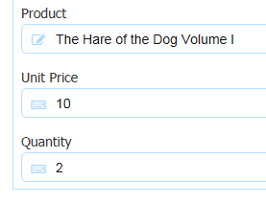

* Click on **Work on Tasks**

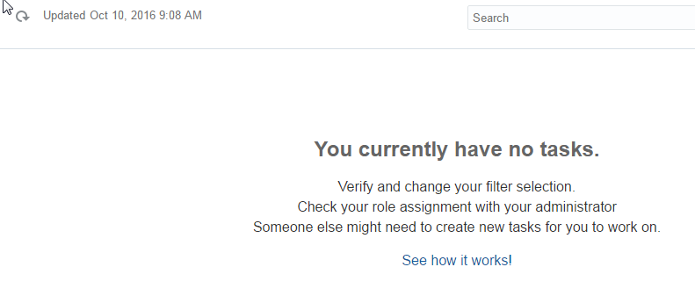

* Why is this ?
* Check the audit trail (Tracking)
  + Remember to also select **Completed**

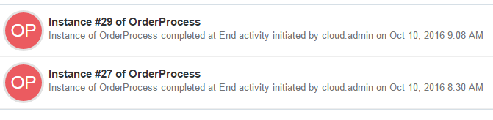

* **Check** the details of the latest instance

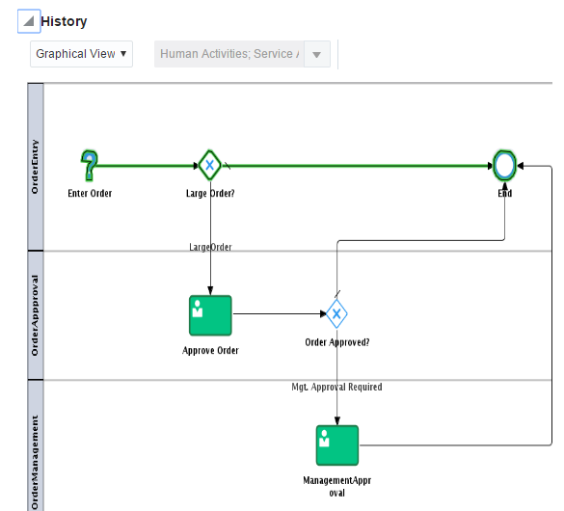

You can see that, because the order was less than £100, it did not require approval.

Try a second test. Click on Home and create another instance. This time create an order for more than $100.

In the Order Approval, we will REJECT the large order (>£100). Then do the Management Approval and review the Audit trail.

* Enter the order
* Look at Tasks – it should be there at the Approve Order Stage
* Reject the Order
* Look at tasks again – it will be at the Management Approval Stage
* Approve the Order
* Review the History (Tracking)

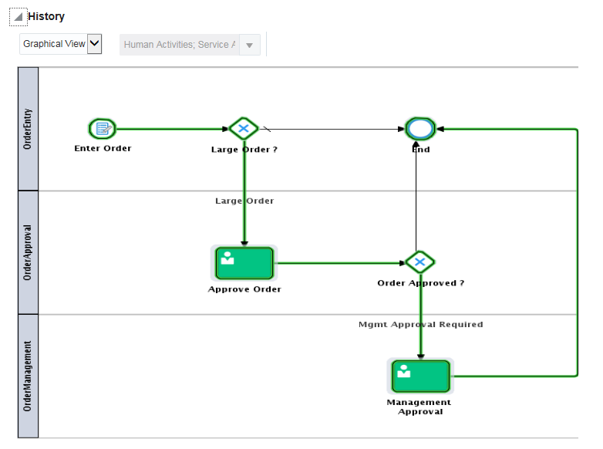

## Congratulations– You have finished the Lab !

### Bonus Labs

We have a small (bonus) lab that demonstrates the integration to Documents Cloud Service.

If you did not get the desired result we have an application that you can import. Follow the steps below to import a solution to this part of the lab, otherwise skip to the section on Document Cloud Service Integration.

## 8.0 Importing the solution

You can very easily import a PCS application into your space.

We have provided you with a demo solution for the lab. It is in the file - **AA01OrdersApp.exp**

You only need to import this file if your process is incomplete – otherwise skip to the section on Document Cloud Service Integration.

Steps to import –

* Click on your **Space** link.

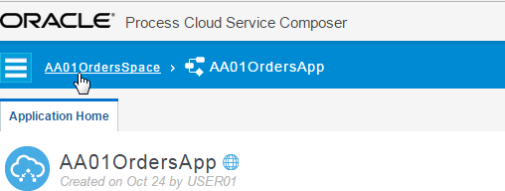

* Click **Create**

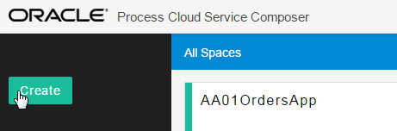

* Select **Import Application**.

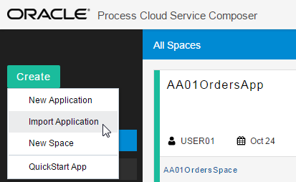

* Select the **.exp** file
* Rename the application to **Solution2OrdersApp**
* Make sure your **Space** is selected.

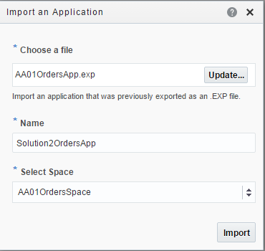

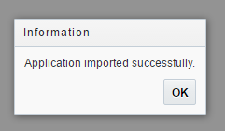

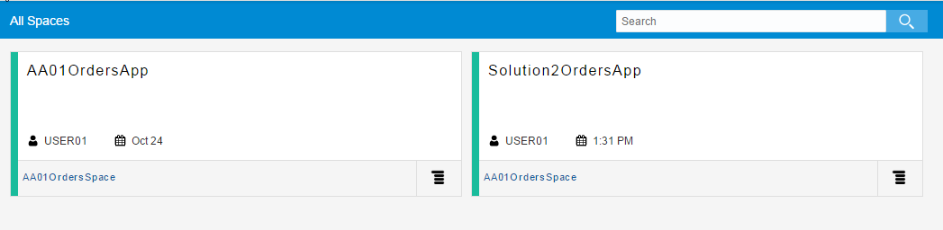

## 9.0 Document Cloud Service Integration

This is a bonus lab, so to speak. We all know how often processes involve documents; for example, our orders process may require legal documents, if the products are going to be sent to a particular country.

For our particular example, let’s imagine that Irish orders require legal documentation.

* **Open** your application
* Click on **Documents**

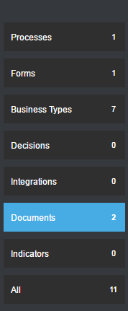

Note: This shows the default folder that will be created in Docs CS, when a process instance is created.

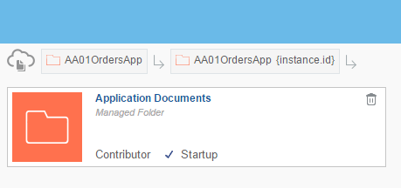

You see the key is set to the internal {instance id}.

Per default this folder is visible to all process participants.

* Click on **Application Documents**
* Change the folder name to **Order Documents & Save.**

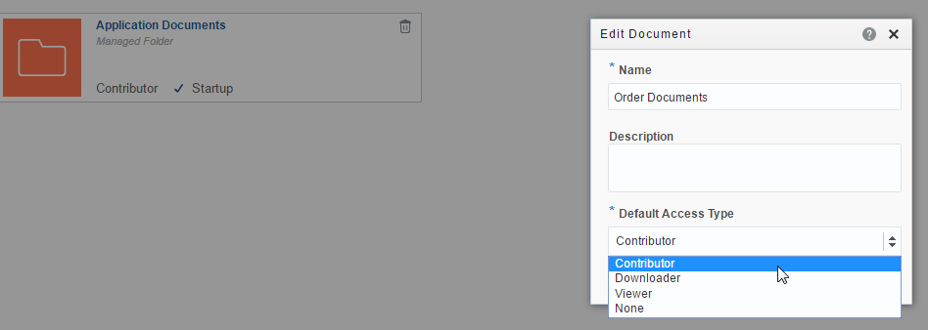

Note: There are 4 access types for folders. **Contributor** can add files to the folder. **Downloader** can download files from the folder. **Viewer** can only view the files. **None** means the user has no access to the folder at all. Leave this folder as Contributor.

* Add a new folder called **Legal** by clicking on the **+**

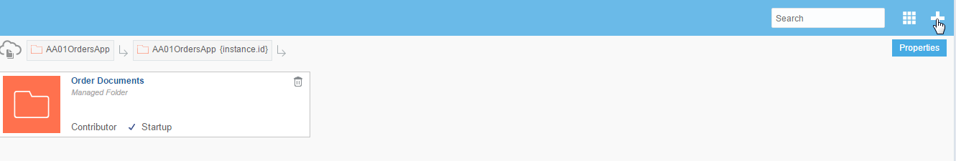

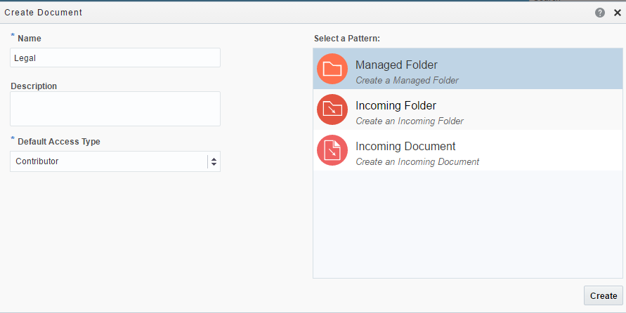

Note: There are 3 patterns available. **Managed Folder** means the folder is defined at design time and will be available once the process has been instantiated. Choose **Incoming Folder**, if you want your process to be instantiated on the creation of a Docs folder. Choose **Incoming Document**, if you want your process to be instantiated on the upload of a document to a Docs folder.

In this case, we will stick with **Managed Folder**.

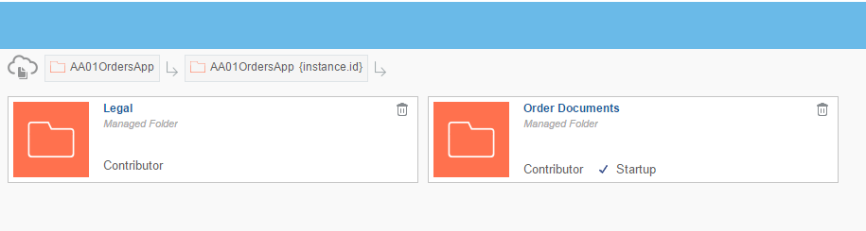

In our simple scenario, only approvers can upload documents to this folder. Managers can only view documents in this folder.

* Open the **Process**

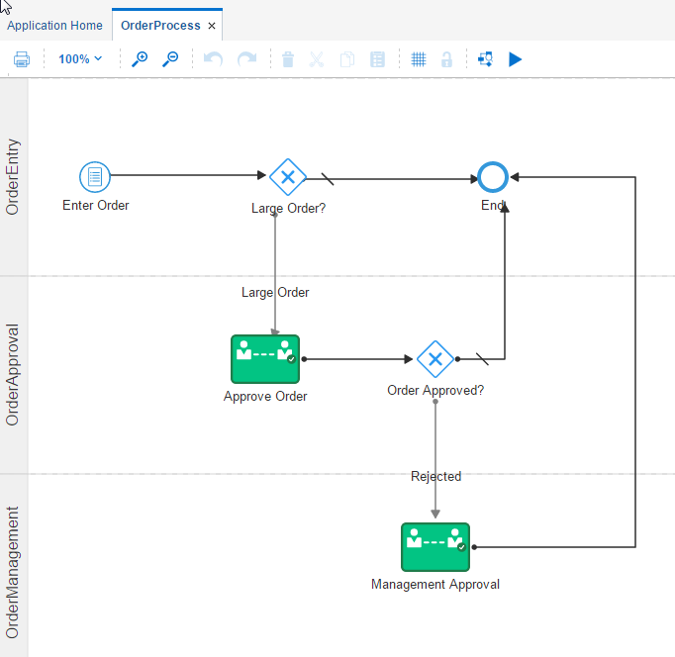

* Select **Approve Order** and click on **Properties**.

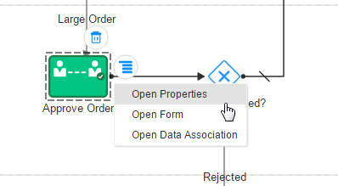

* Click on **Documents**

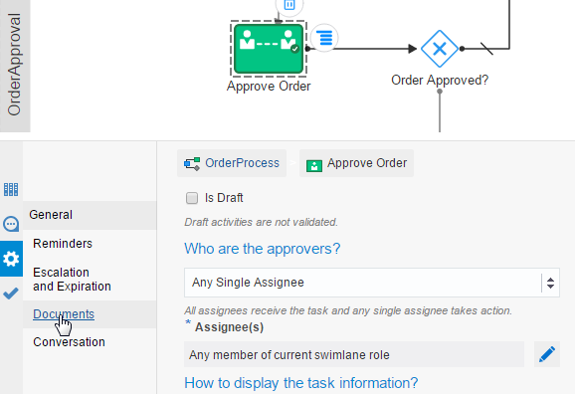

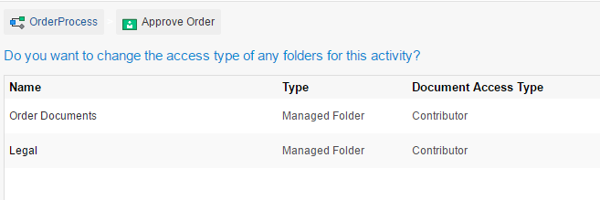

Note: We are ok with these settings for the Approver.

But what about the Manager?

* Select **Management Approval** and click on **Properties**.

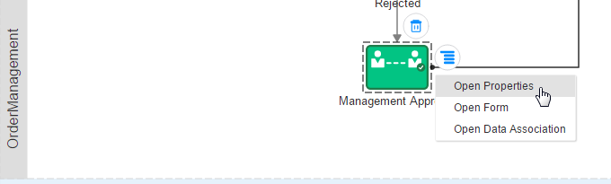

* Select the Documents options

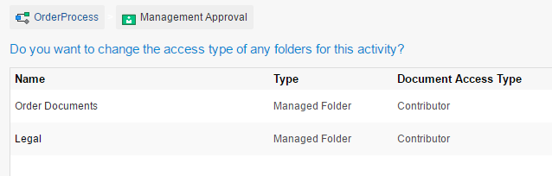

We need to change the **Document Access Type** to **Viewer**.

* Click **Override** and set to **Viewer**

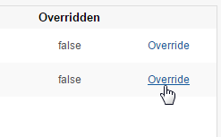

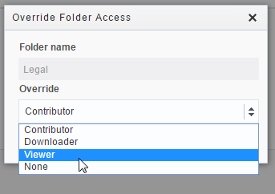

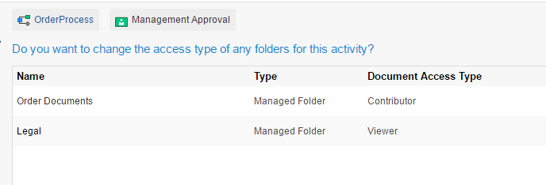

* Click **Save**
* Click **Test** and validation is passed
* Click **Deploy**
* Click **Try in Workspace**

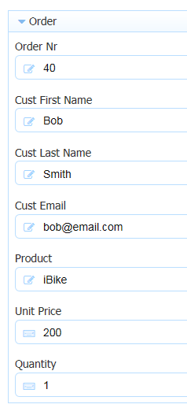

* Make sure your total order value – item * price is > 100 so we go to Approval
* **Before you Submit** the form, Look over to the right of the page, you will see the **Docs** icon
* Click on it.

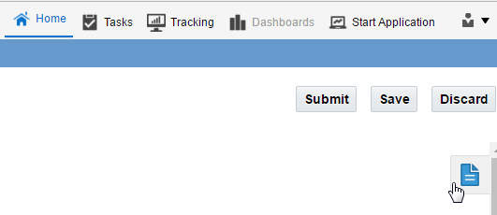

You see the default **Orders Documents** folder

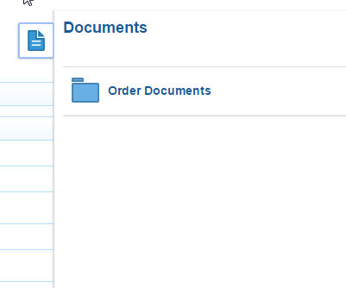

Don’t add any document yet. We will do that at the Order Approvals stage.

* Submit the Order, by clicking **Submit** (you can close the Documents window with ‘X’)
* Open the **Approve Order** task.

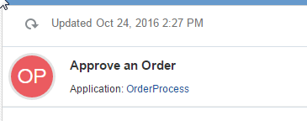

* Click on the **Documents** icon, to the right of the page.

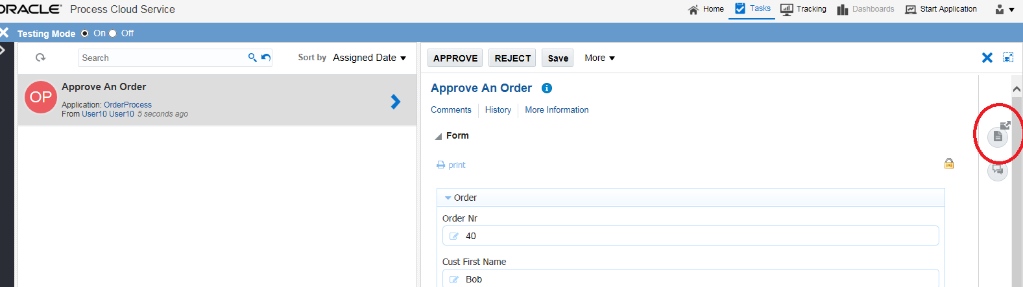

Note: You see the 2 folders.

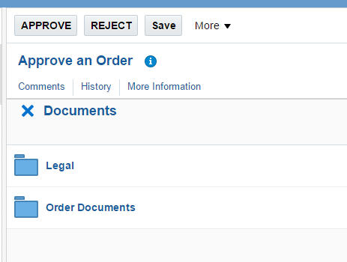

Now you will add a doc to the **Legal** folder.

The doc is called **Export conditions for Ireland.pdf.**

* Open the **Legal** folder

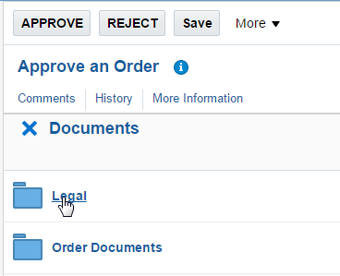

* Click **Upload**

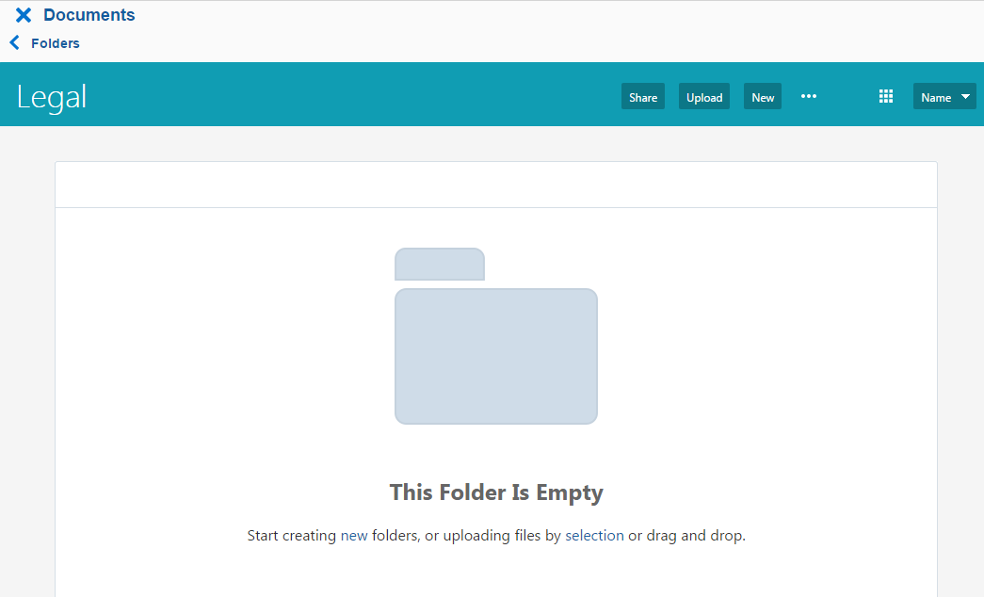

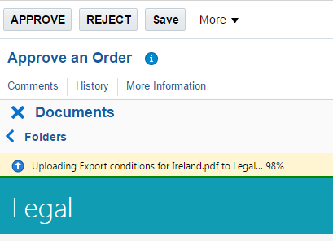

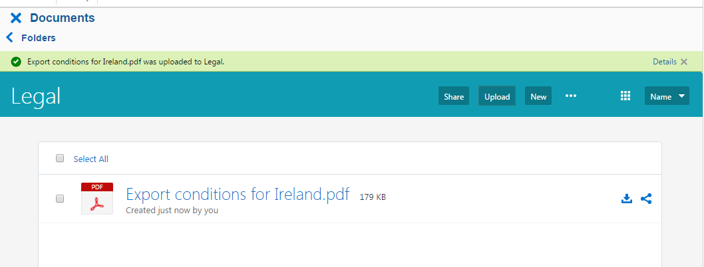

* Reject the Order, so that it goes to **Management**
* Open the **Management Approval** task

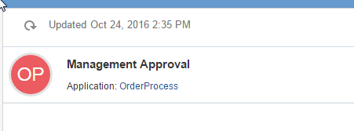

* Click on the Documents icon

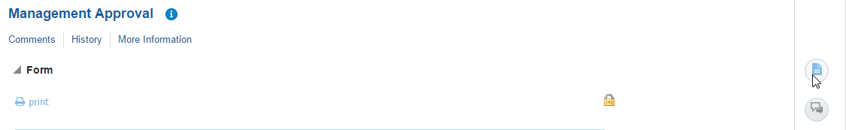

* Open the **Legal** folder

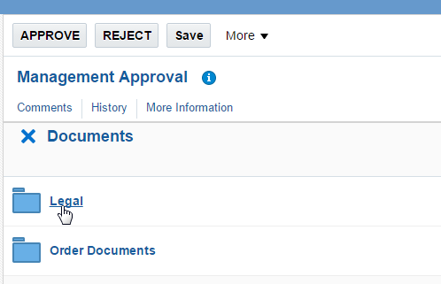

Note: You only have **Viewer** permissions.

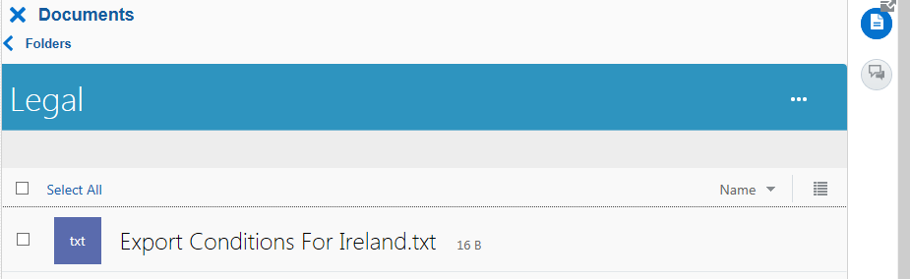

**End of Bonus Lab.**